GROUPED BAR CHART - DISTRIBUTION OF ANSWERS FOR QUESTION 1
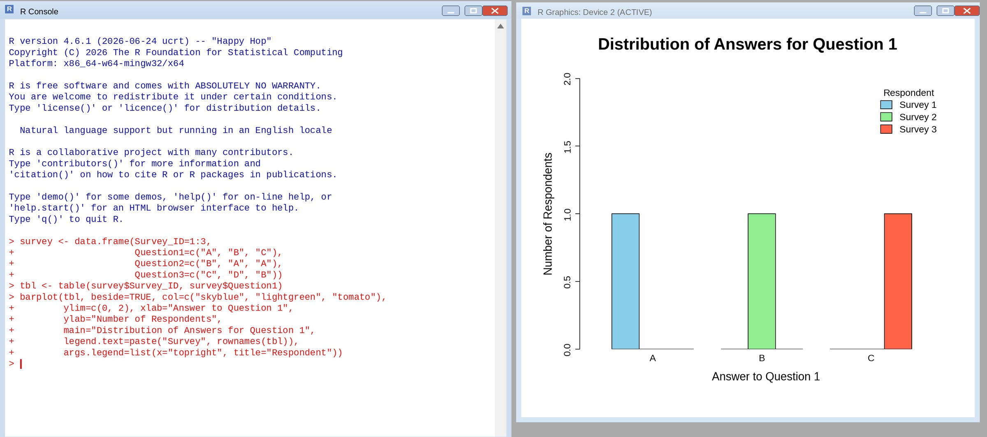
STACKED BAR CHART - OVERALL DISTRIBUTION OF RESPONSES
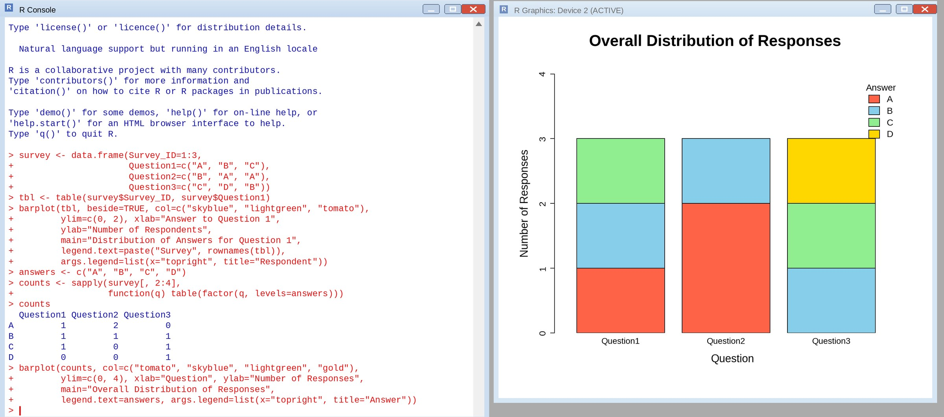
TABLE - SURVEY RESPONSE DATA
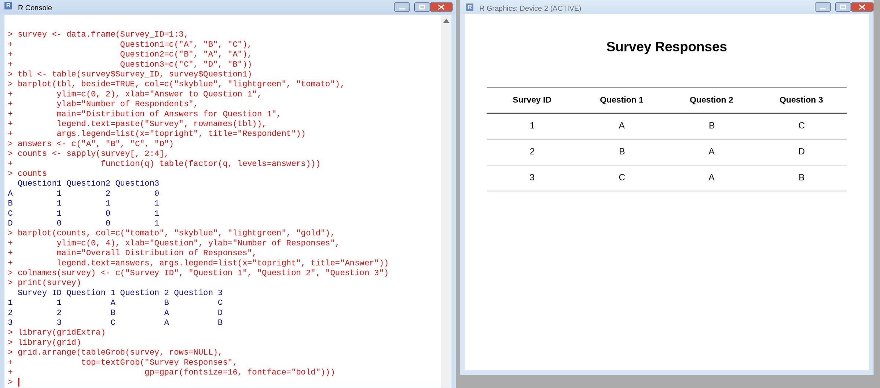
TABLEAU DASHBOARD - GROUPED BAR CHART, STACKED BAR CHART AND TABLE
